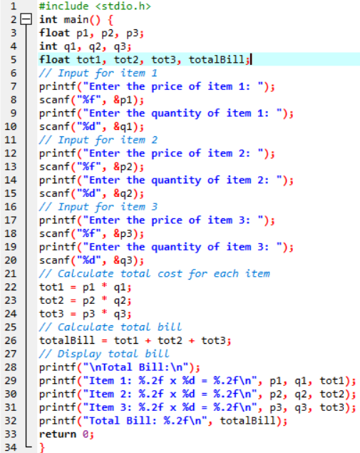
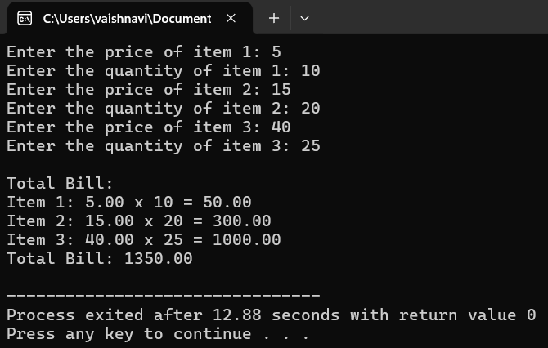
Write a C program to calculate the total bill for a customer's grocery purchase. The program should ask the user to input the price and quantity of three different items. It should then calculate the total cost for each item by multiplying price and quantity and finally display the total bill.

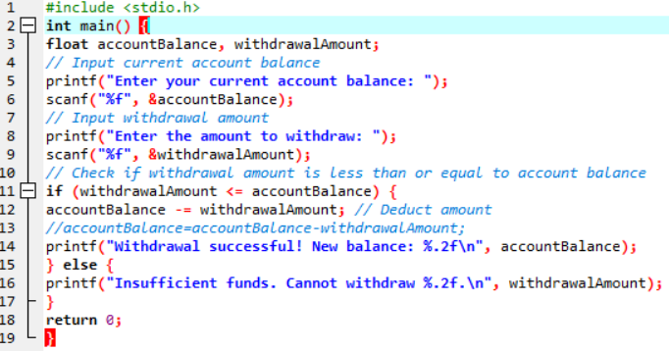
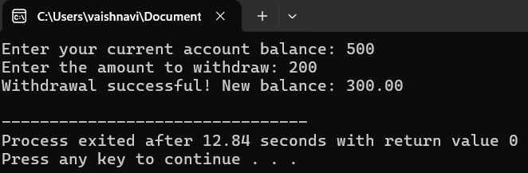
Write a C program that simulates an ATM withdrawal. The program should: Prompt the user to enter the current account balance and the withdrawal amount. Check if the withdrawal amount is less than or equal to the account balance. ○ If yes, deduct the amount from the balance and display the new balance. If no, display a message indicating insufficient funds

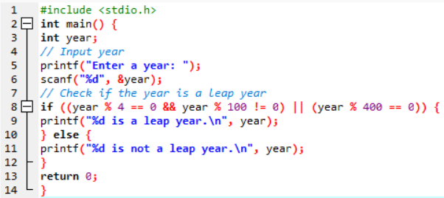
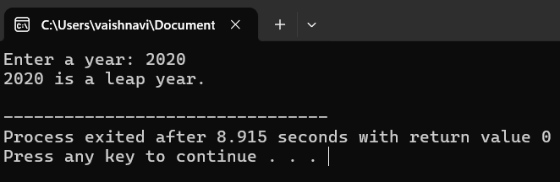
Write a C program to check whether the year is a leap year or not.

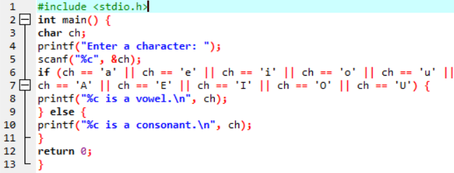
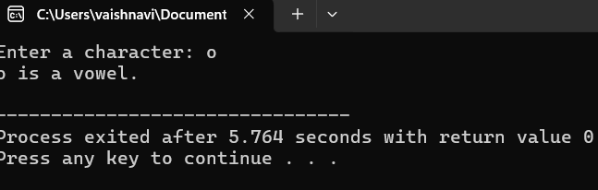
Write a C Program to Classify a Character as Vowel or Consonant

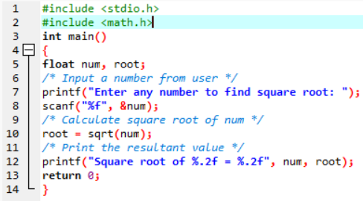
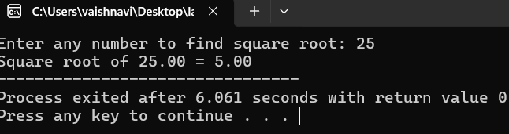
Write a C program to find the square root of a number

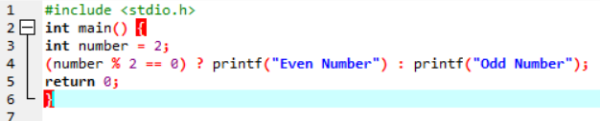
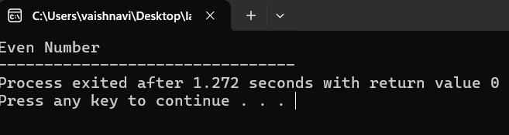
Write a C program to find odd or even number using ternary operator.

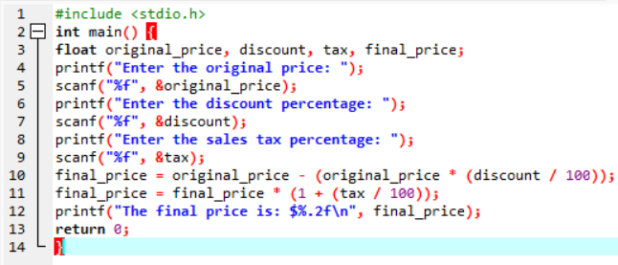
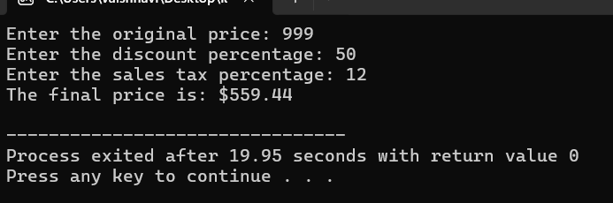
Write a C program to calculate the final price of an item with a discount. The user should input the original price, the discount percentage, and the sales tax percentage. The final price should be calculated as follows: final_price = (original_price - (original_price * discount/100)) * (1 +tax/100) Demonstrate how to correctly handle operator precedence in this calculation.

